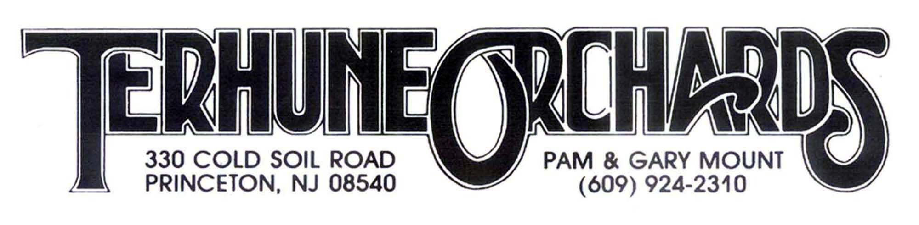

Blueberry Bash Contest

Recipe Submission Form 2021
Must be submitted with sample of actual baked product!

Name: __________________________________________________________

Address: ________________________________________________________

Phone #: ____________________________________

Email: _______________________________________

Recipe Title: __________________________________

Recipe: _________________________________________________________

------------------------------------------------------------------------------------------------------------
Contest rules: Recipe and actual baked product for tasting should be brought to the Farm Store at 330 Cold Soil Road no later than 12 noon on Sunday, July 11th.

By submitting a recipe you are allowing Terhune Orchards to publish it in our newsletter, website and share with our customers.

Prizes: $100 Terhune Orchards Gift Card for winner
$50 Terhune Orchards Gift Card for 2nd prize
$25 Terhune Orchards Gift Card for honorable mention

